Figure 1 blasting along towards Bradwell on my first trip out of the River Crouch.
Figure 2 Victoria ready to go on the day of her launch.
Victoria, PBO
I’ve always wanted a Jeanneau Sun 2000, ever since I was 8 or 9. I don’t know what it was about this pretty trailer sailor that made me dream of owning one in the distant future; maybe it was her sleek lines, or the example which appeared unloved which sat at Fambridge Yacht Haven. This is where we keep our family boat, a Jeanneau Sun Odyssey 40. I was determined, one day, to rescue this boat, Victoria. I created a log book about Sun 2000s, recording every time I saw one and what modifications I would do, as well as my planned adventures. The first time I saw one for sale firsthand, I begged my parents to go into the broker and ask for a viewing; very kindly, the broker let us look around ‘Jackhannah’ after realising my enthusiasm for them. I excitedly recorded my thoughts in my log book, and even showed my Year 5 teacher my extended writing about it! However, my dreams about them stayed firmly as dreams; I certainly was not in the position to buy a cruiser, at least not soon – or so I thought…
Figure 3 Victoria as I found her in Fambridge, looking unloved.
Every time I went with my parents to the boat during the offseason, I would explore and imagine what I would do to rescue Victoria. One time, I discovered that the washboards were not locked down fully, and managed to gaze into her sad interior, circa 2017. My eyes were met with mouldy headliner, floorboards under an inch of water, and my nose was met with the classic mould smell which repulsed 10 year old me! Furthermore, where she had been incorrectly put on the trailer the last time she had been hauled out, her hull had buckled and dented under the pressure of the roller. However, this didn’t dampen my spirits, and indeed seemed to fuel my passion; I had, inadvertently, been hit with the ‘project boat blinkers’, that have captured the minds of many sailors. Despite this, I still did not act upon my interest. It would take a few more years yet!
Figure 4 the cabin the day I bought her - you can see how grimy it is.
On the 2022 shakedown cruise to Burnham-on-Crouch from our club further upriver, aptly called Up River Yacht Club, my sister and I sailed with my Aunt Penny down to the marina. Over dinner later that night, with friend Andy, they encouraged me to get in contact with the owner. This was all the encouragement I needed! I wrote an email with my parents, stating my love for Sun 2000s, and after it was double, triple and quadruple checked, we sent it to Fambridge, requesting them to pass it onto the owner. They very kindly did, and I waited, with bated breath, for an email reply. However, after weeks of waiting, nothing appeared in my inbox, despite my earnest checking every day. My naivety was on show here; it turned out the owner, Simon, had replied soon after the email was forwarded, but it had automatically been sent to my spam folder, and I hadn’t thought to check there. Luckily, my Dad asked if I had checked my spam folder after a couple of weeks. To my excitement, I found the email there; however, on reading, my mood became more sombre. Simon explained the sad reason for Victoria’s seemed abandonment. Simon had sailed Victoria with his brother on the river Crouch after purchasing her in 2007. However, sadly, his brother had passed due to cancer in the early 2010s. Understandably, Simon could not bring himself to sell her or to sail her, so she sat, slowly lapsing into a worse and worse state. Incredibly sadly, Simon had then been diagnosed himself with Cancer; this meant he was looking to sell the boat before he passed away himself.
After this initial digital contact, we emailed backwards and forwards, and eventually arranged a Sunday to meet when Simon was well enough. The whole weekend was hectic; my Dad and Sister were on a Brightlingsea cruise, and I had my Duke of Edinburgh Award the Friday-Saturday. My Mum and Grampa were initially going to come with me to Fambridge to meet up with Simon and his partner Dawn, however my Nanna was desperate to go to London to pay her respects for the Queen who had passed that week. My Mum decided, therefore, to go with my Nan to London on the Sunday, with just my Grampa and I heading to view the boat. That Saturday, I couldn’t sleep due to my excitement! The last words my mum told me before I went to bed were “remember, you aren’t buying her, just looking at her, just remember that!”
The morning finally arrived, and although we had agreed to meet at 11:00 a.m., we left at 9:30 a.m. as I could not bear to wait any longer! We arrived at 10:00 a.m., and had a good look around the boat, refamiliarizing myself with Victoria. Eventually, Simon and Dawn arrived, and we met for the first time. After handshakes and friendly chat, Simon and I walked over to the boat. He asked me about my dreams for the future with her, and he told many stories of his sailing career on the Crouch, as well as chartering boats in the Mediterranean. We then discussed the condition of Victoria, and went through her inventory; in essence, she was ready to go, with all her spars, sails, anchor etc. We had worked out a rough deal for what Simon wanted for Victoria via email beforehand. I would pay £1000 (all my Birthday & Christmas savings, plus around £200 my parents loaned me), and raise £2000 for Macmillan Cancer Support by the time I was 18. After inspecting her, Simon and I shook on it; she was mine!!
Simon and Dawn had brought some of Victoria’s equipment with them in their car, like the inflatable and sails (which had been dry stored and were in good condition, especially the asymmetric which had apparently only been used a couple of times). We unloaded all of this into my Grampa’s trusty Volvo, smiling from ear to ear; I could’ve never imagined actually owning Victoria, especially at 14! After a very thankful goodbye, Dawn and Simon left, and my Grampa and I went for a celebratory tea in the boatyard’s café. I then called my parents, who shared my excitement. We organised to collect the rest of her gear the following Thursday and had until the end of September to get her home. Simon had also had a lifetime subscription of Sailing Today from magazine no.1, up until no.300 and we also took these gratefully, both to read and to leave at our home club.
The next challenge was to get Victoria to URYC just a few miles up the river from Fambridge. We had been given the trailer board, and the trailer she sat on had internal electronics. This all seemed fine until we went to plug it into the car; someone over the last 10 years had chopped the car-end off, probably assuming it had been abandoned. Luckily, my uncle Tim had a Phantom trailer board which was just about long enough to reach the stern. The tyres were luckily in good enough nick for the short drive back to Hullbridge. However, on the way back, we all thought it had gone wrong! A ratchet strap’s tail holding her down had fallen under the wheel and had started smoking – we had all assumed the tyre had blown out. Luckily, it wasn’t the case.
Figure 5 Victoria on her trailer behind Tim's car - note the unconventional light board!
Victoria survived the trip back, and now the worked started…
A couple of weeks later, using the club hoist, we repositioned her on the trailer, and put the mast up, although this was a struggle; we couldn’t work out how to use the mast raising kit (it turned out we were missing a vital pole), so used the next best alternative: not a crane, but lots of help and more importantly muscle from family – uncle Tim and cousins Sam and Harry. We managed to get it up but couldn’t work out how the rigging worked: the lowers on one side were loose, and the other side were incredibly tight; obviously this wasn’t correct as it made the mast into a slight banana shape but left it for the moment as the mast needed to come back down anyway as the spreaders were only bodged into place as we could not find the proper bolts. As I thought, a jetwash soon revealed a much better looking boat, making hull, and most notably deck and cockpit white again as opposed to an unattractive yellow. Cleaning was the order for the rest of ’22, where hot soapy water revealed a usable cabin. URYC’s status as a ‘member’s club’ made jobs using the tractor and dumper truck much easier, and more importantly, free!
Figure 6 & 7 the headlining and cockpit (right - before cleaning, left - after cleaning).
Figure 8 & 9 the lockers cleaned, before and after
Where the anchor locker drained excess water within it, it passed through a tube in the cabin to the outside. Where this tube was attached, it had leaked rainwater into the cabin. This had destroyed the wooden boards underneath where the cushions sat. These were obviously far beyond repair, so I had to bear the cost of marine plywood to cut some new ones. Family friend and boating legend Gerry Ledger cut them to the outline of the old ones, and I spent a week varnishing each side, to protect them against the damp environment of a boat on a swinging mooring with minimal ventilation. My Dad and I spent far too long fitting them; as with all boat jobs, it wasn’t easy, as the new boards were slightly thicker than before. Obviously, the boards could only hinge up 90 degrees, and due to the walls of the cabin being angled at more than 90 degrees, the hinges would pull out of the plywood should they get pushed against the cabin wall. We eventually managed to bypass this problem by raising the hinges, which meant they could rotate more than the original 90 degrees.
Figure 10 Victoria in the hoist, as I could not access the keel whilst on the trailer to antifoul.
Victoria also came with a 4hp 4 stroke Suzuki outboard, which Simon had stored vertically in his garage. Luckily for us, that meant after a quick service, it ran well. As she did not have a VHF, I began the search for a DSC handheld. This coincided with some correspondence between myself and Timothy Long, the up and coming offshore sailor who sailed around Britain aged 15 in 2020. It turned out he was selling lots of his equipment from this trip, so I purchased a Standard Horizon HX870e, as well as 105a lead acid battery, using profits from selling old sailing equipment of mine on Facebook Marketplace.
Whilst I was working on the boat, Simon’s struggle with his terminal cancer continued. His limited time simply encouraged me to get on with the fundraising, so he could see it be completed before he passed away. My parents helped me to organise a charity quiz night at our sailing club (who kindly waved the hire fee) with friends and family. Around 70 attended, and overall we raised an incredible amount of money, almost £900. With huge kindness, family friends Sue and Julio Pelling donated around £130 to get the number up to £1000! Another family friend, Jackie Honour, makes chutney and donates the profits to different charities; she put this year’s profits towards my fund, getting us to around £1400. Another £500 was gratefully received from friends who could not make the quiz, and I gave the final £100 from Birthday and Christmas money received. Incredibly, we had raised the £2000 just after Christmas, and told Simon of our donation to Macmillan.
Figure 11 the quiz night in swing at our sailing club
Incredibly sadly, Simon passed suddenly as we moved into the start of 2023. I’m simply glad he knew we managed to fundraise the money, and I hope he is proud, wherever he is, of what I have done with Victoria.
Moving onto a cheerier note, Victoria was progressing slowly as spring and summer emerged. I had originally hoped to get her into the water before the May half term, however school and exams got in the way. I had her ready to go in mid-July, however progress was to be thwarted once again; when we went to mount the rudder, we discovered (or, in effect, didn’t discover) the rudder pin was missing. Although we could’ve fabricated something ourselves, I decided to do it properly and to purchase the part from a Jeanneau dealer, even at the cringe worthy price. £150 paid for what I think is probably the most expensive stainless steel pin in existence, and eventually, 5 weeks later it emerged in the post. Due to my school holidays, I was at home so went and mounted the rudder the morning it arrived. We organised the boat to go in that night as the tides worked well enough to launch, and Grampa agreed to drive the tractor. I invited Simon’s partner, Dawn, as well as a few other friends that had contributed to the fundraising.
10 years after her last sail, Victoria slipped into the water to the background of clapping! As she touched the water once again, we all celebrated with a cheeky mouthful of Champagne, and my Dad and I took her for a quick sail up the river to sail to my Nanna, who had been unwell. We sailed back under jib, waving at everyone on the slipway!
Figure 12 pouring some Champagne onto her bow as she inched down the slipway.
Since Victoria has been launched, I’ve taken as many opportunities as possible to take her out. My insurance stated I had to have a competent adult onboard, but luckily, one of our dinghy (& newly cruiser) sailing friends had turned 18 not long before, so our first trip was go; we spent 3 days cruising around the river, with lots of anchoring and swimming, as well as a walk around Burnham on Crouch with an ice cream. I also sailed my first URYC club cruise to Bradwell in the River Blackwater, with some challenging conditions; gusting 25 knots made for exciting reaches! Andy Dale, who convinced me initially to email Simon was a fantastic crew for this trip. I’m also planning on a late season trip to the Blackwater, with my Dad and family friend Pete on his Fulmar. Next year, who knows – maybe even a hop across the channel!!
Figure 13 my first trip away, tied up at Fambridge - from left to right: friend Liv, cousin Harry, sister Rosie and me!
Figure 14 swimming off the back of Victoria - note the infamous banana boat.
I’m very proud of Victoria now; she must be one of the smartest boats in the club! I’m sure she holds much more for me, as I plan more adventures – maybe even round Britain one day…
Figure 15 reaching towards Bradwell, credit to my Nanna who was on by uncle’s boat whilst sailing past.
About the Author
Despite only being 16, Jack has crossed the channel 28 times on his family’s sailing boat, a Fulmar and now a Jeanneau Sun Odyssey 40. He has also dinghy sailed from the age of 5, and now often competes in open meetings in his Streaker, as well as regularly competing near the front at his local sailing club on the River Crouch, Essex. Jack aspires to sail round Britain in the future and has been inspired by the likes of Timothy Long and Katie McCabe in their recent round Britain endeavours, as well as Ellen MacArthur in her 1995 trip on Iduna. He plans to sail Victoria further afield in the future. You can follow Victoria’s progress on Instagram and Facebook, under the username @victoriatheboat.

Fig1 | 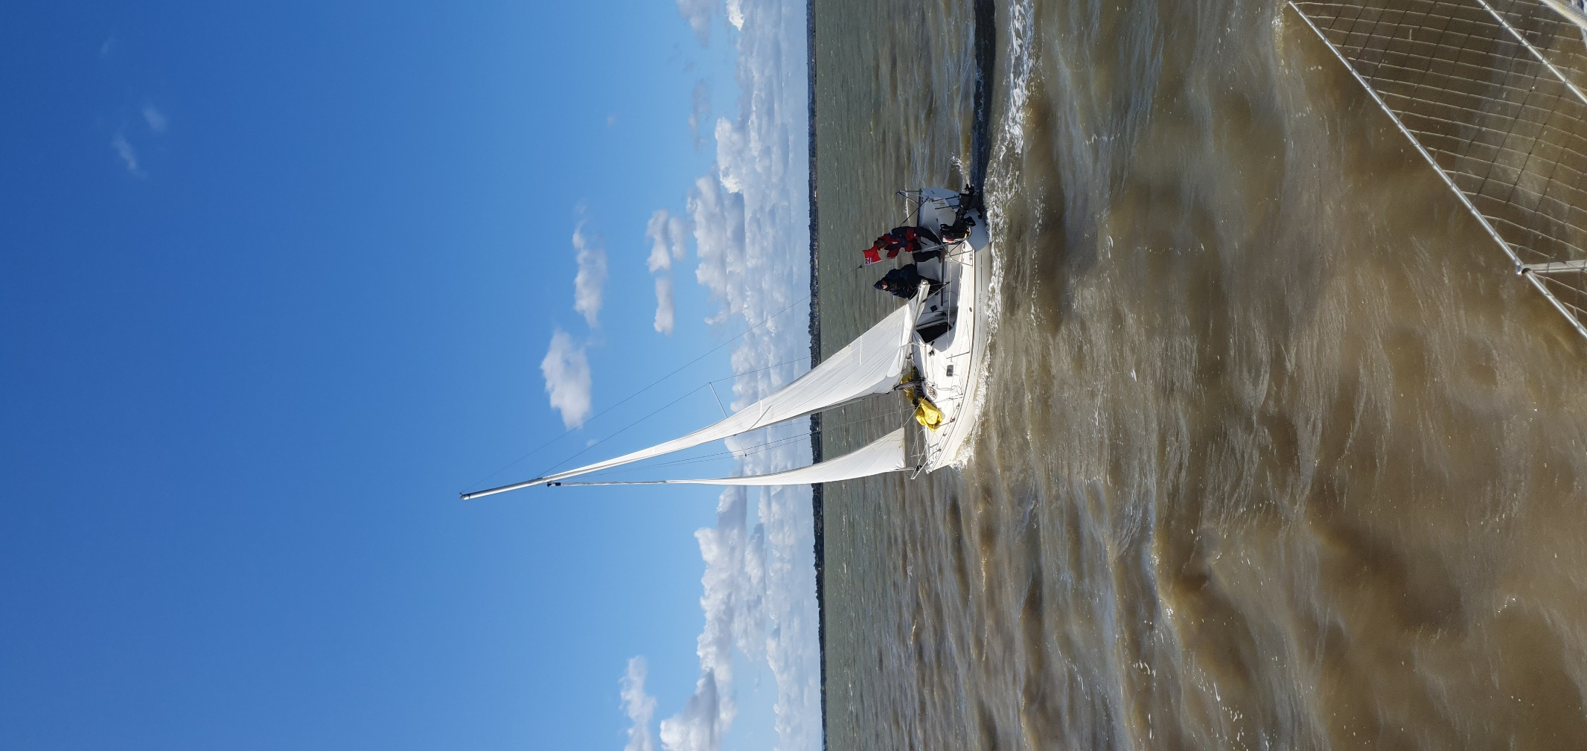
Fig2 | 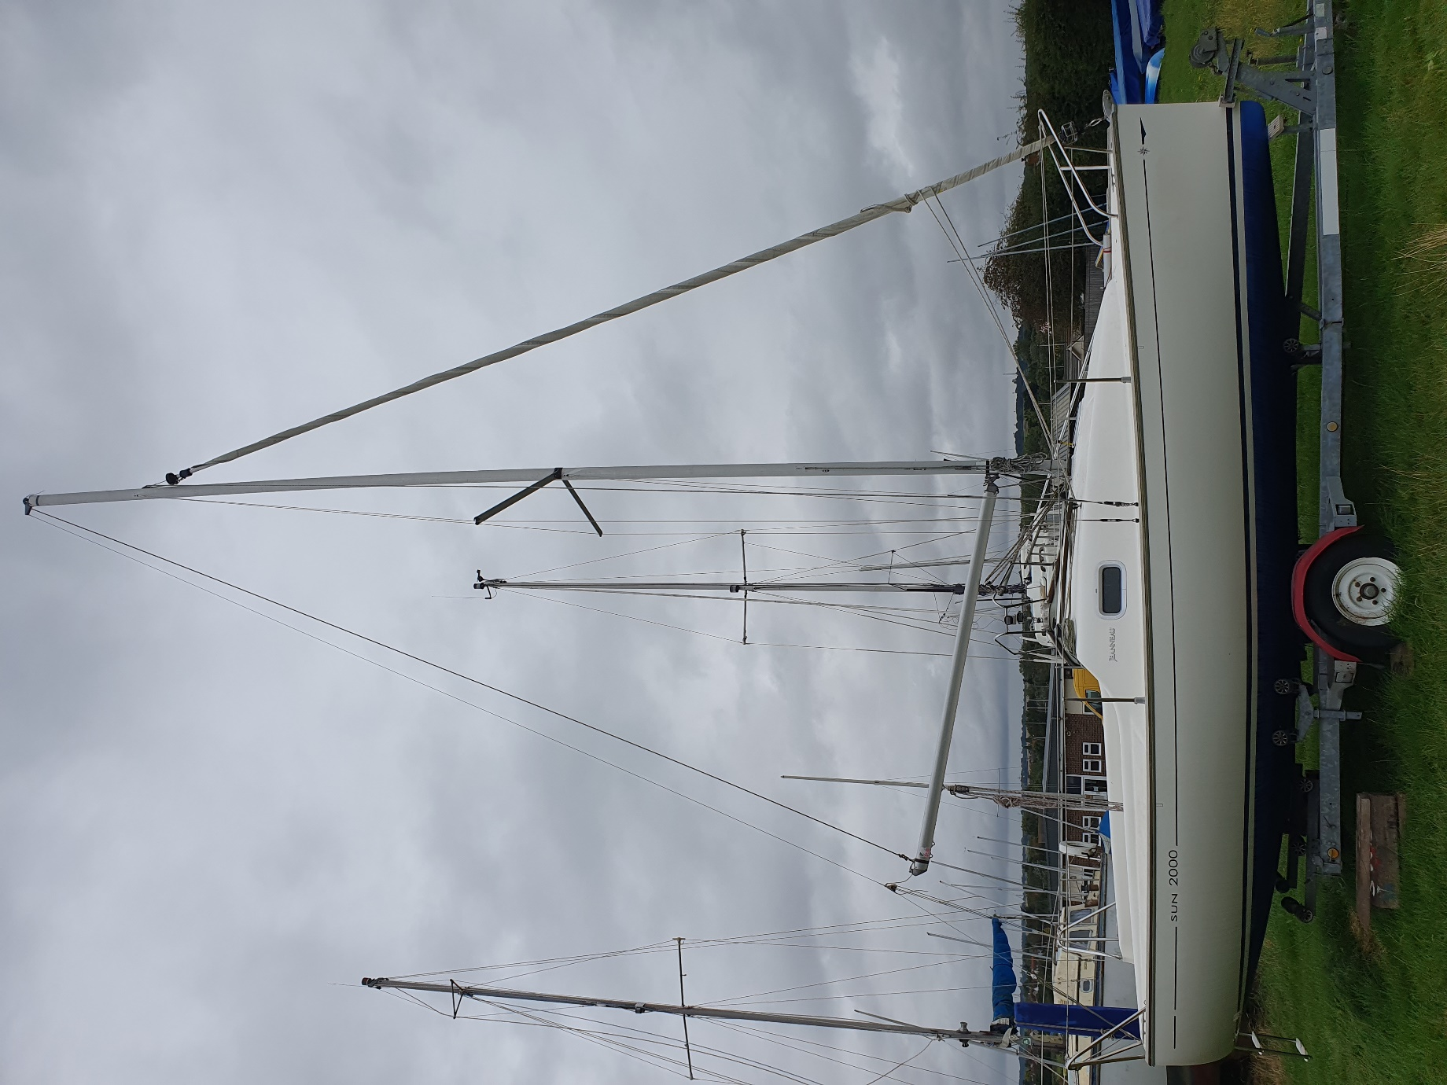
Fig3 | 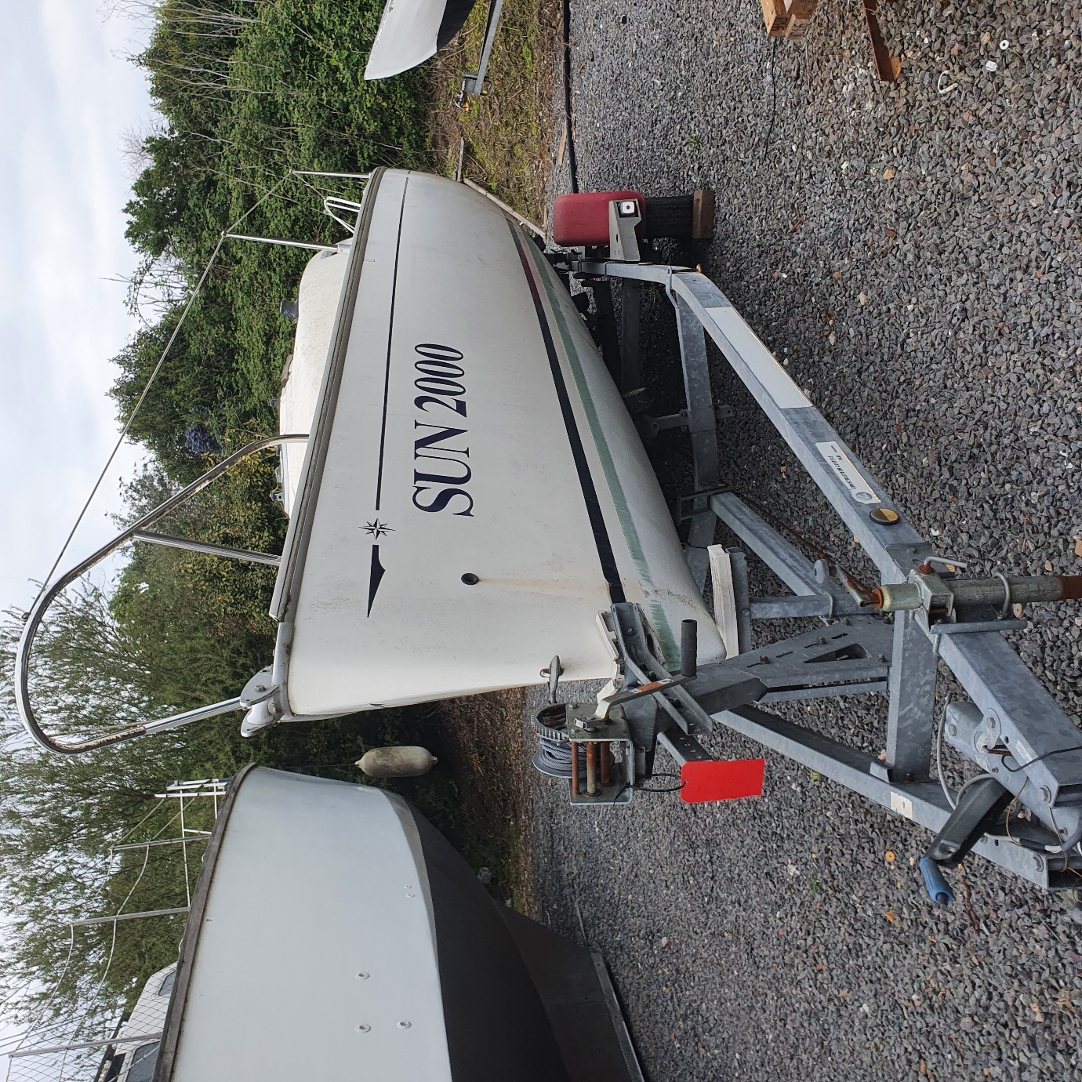
Fig4 | 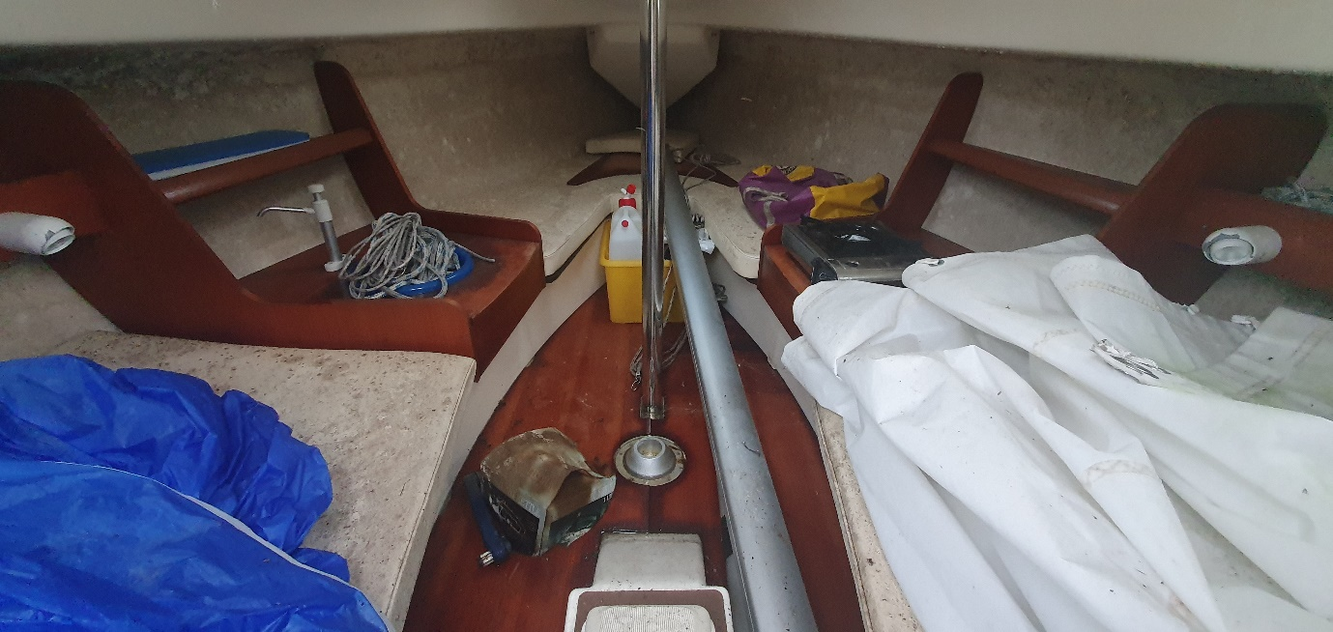
Fig5 | 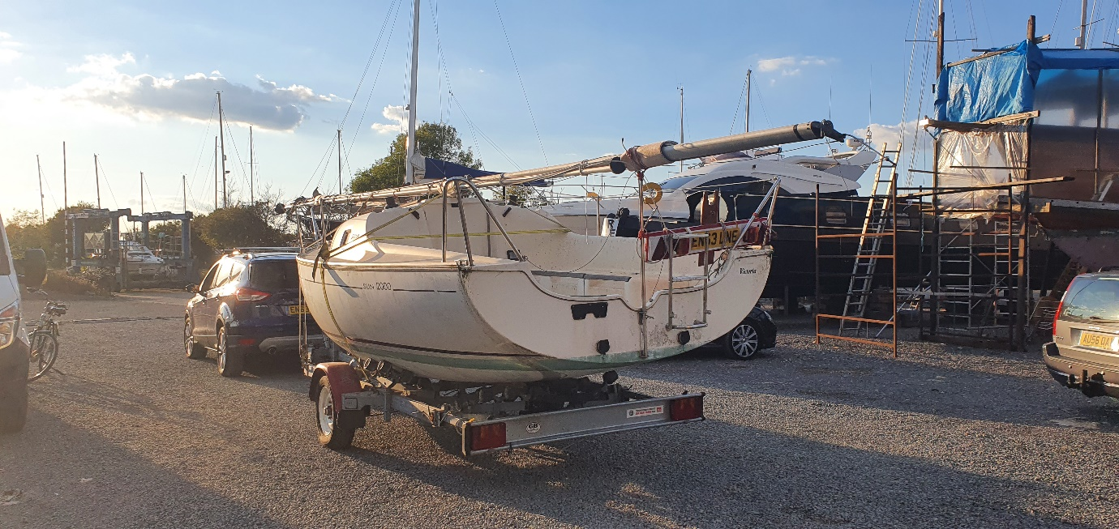
Fig6 | 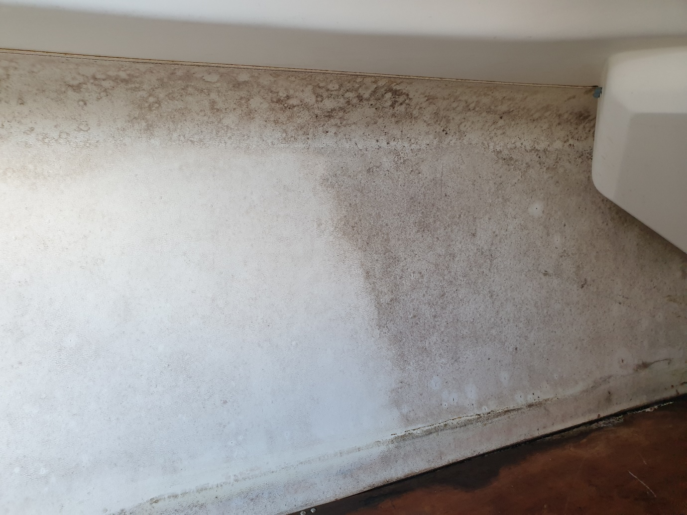
Fig7 | 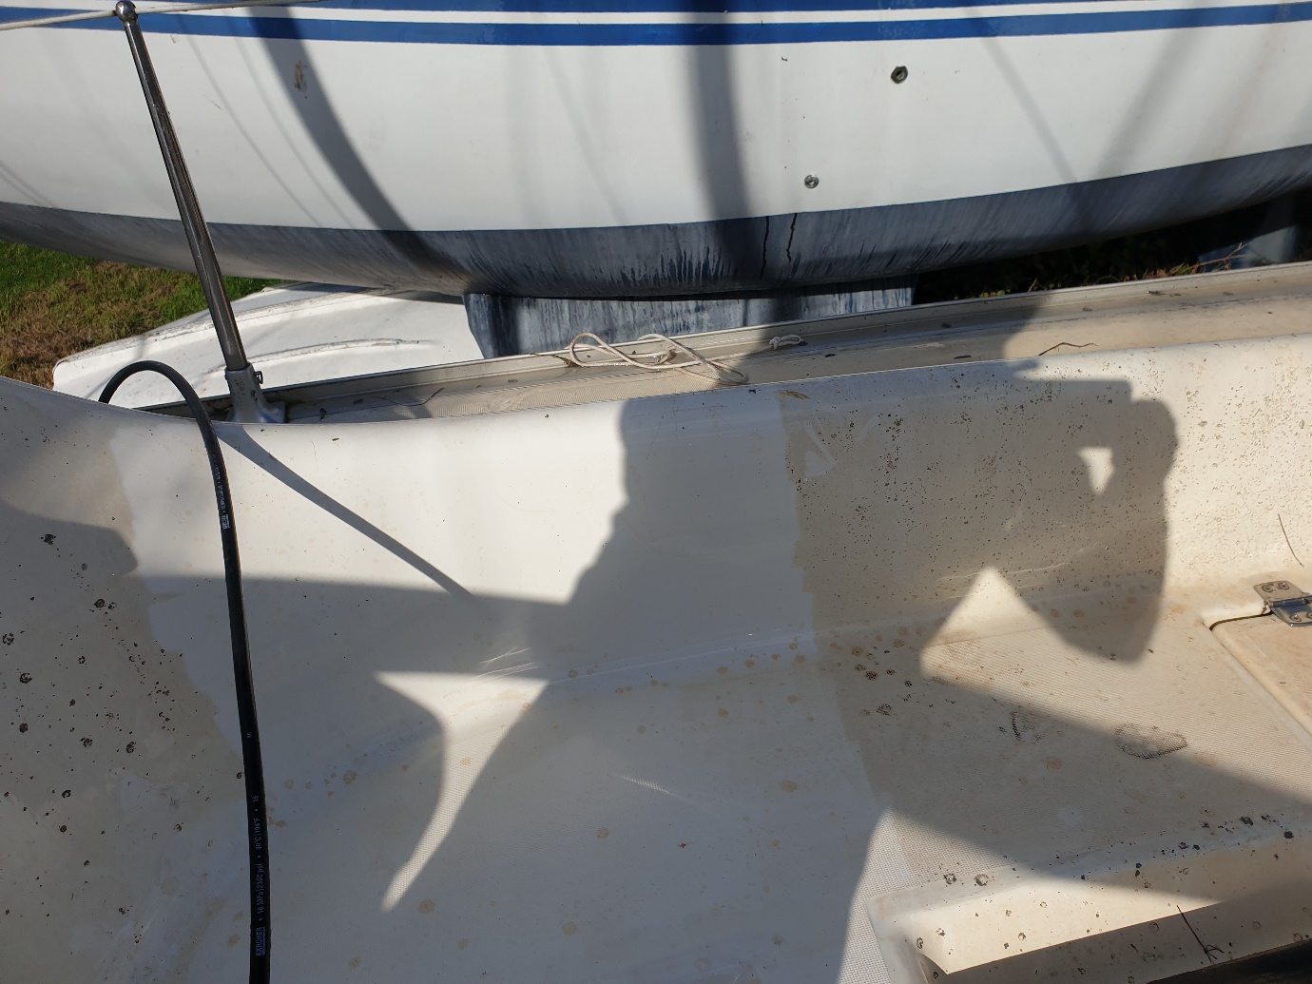
Fig8 | 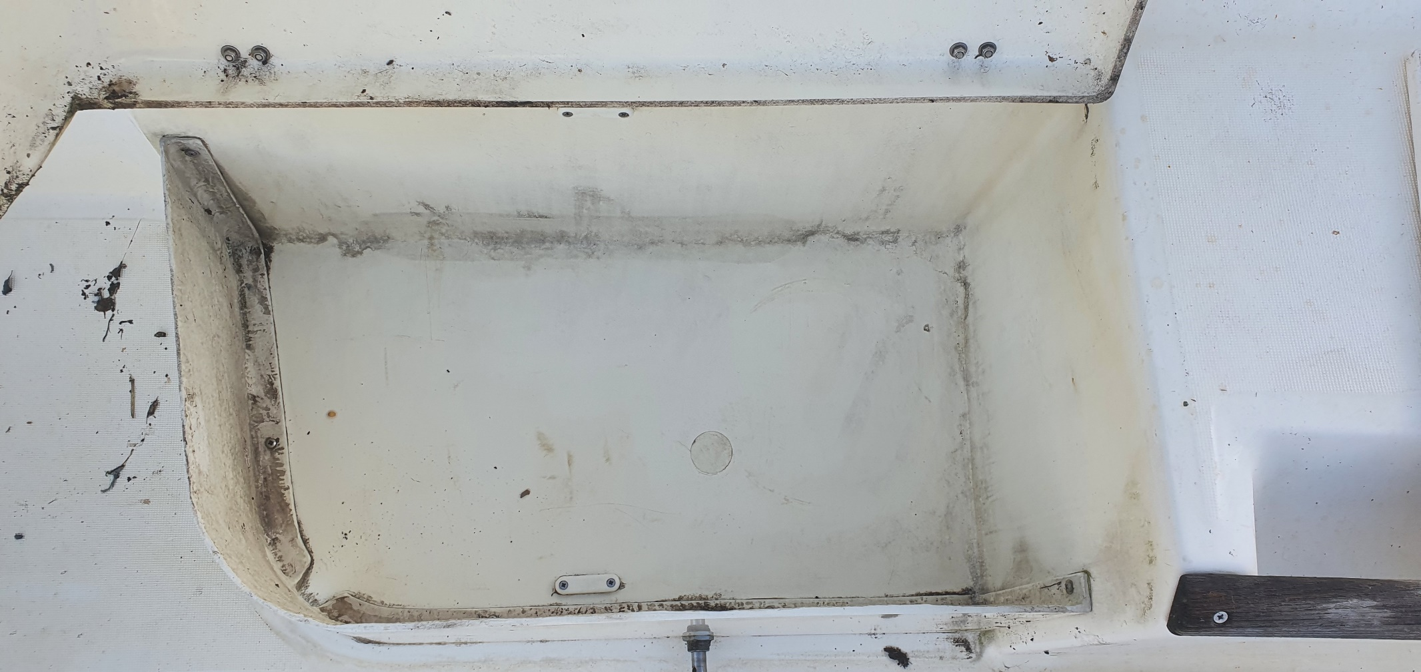
Fig9 | 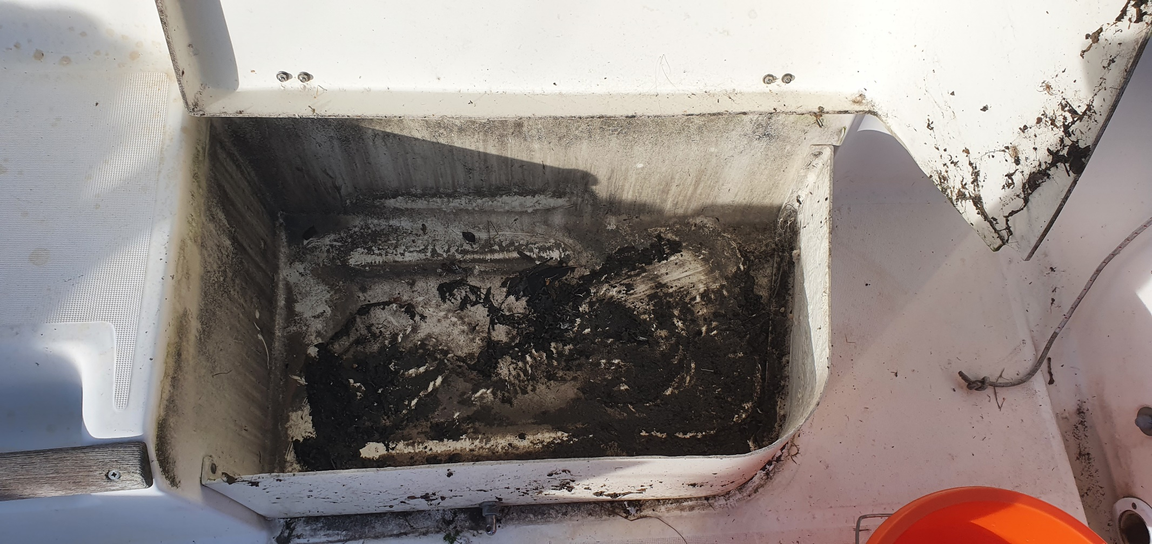
Fig10 | 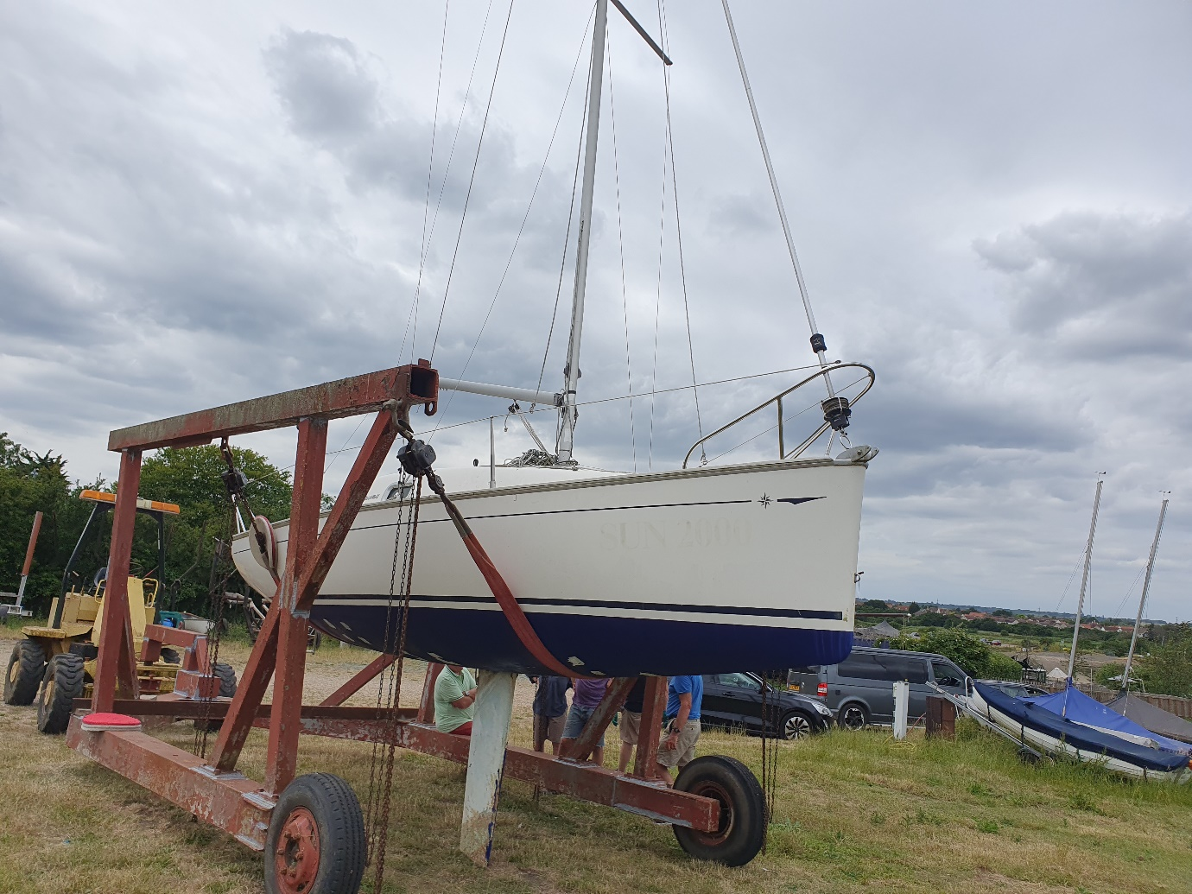
Fig11 | 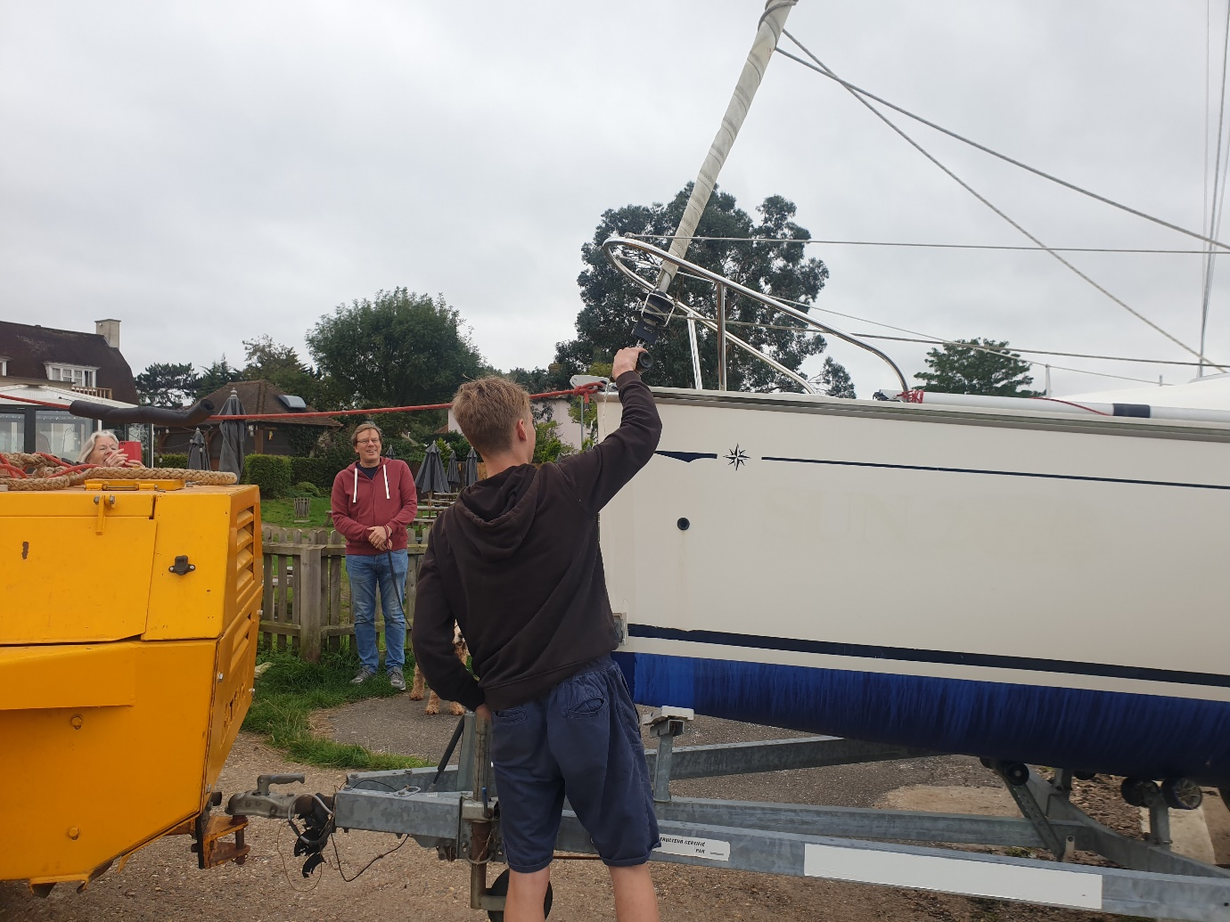
Fig12 | 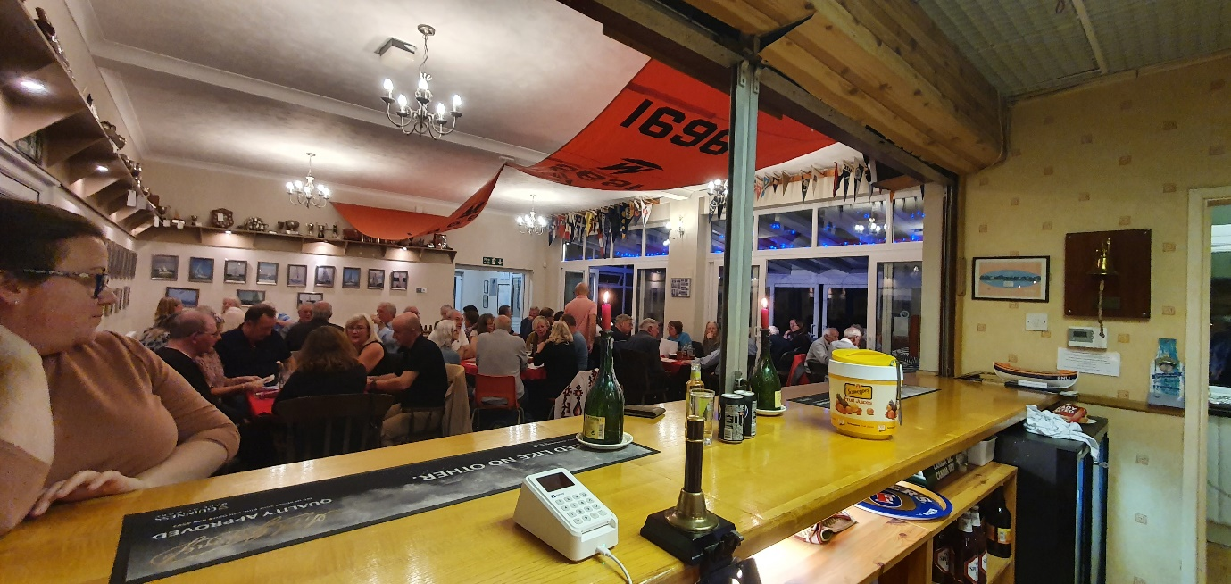
Fig13 | 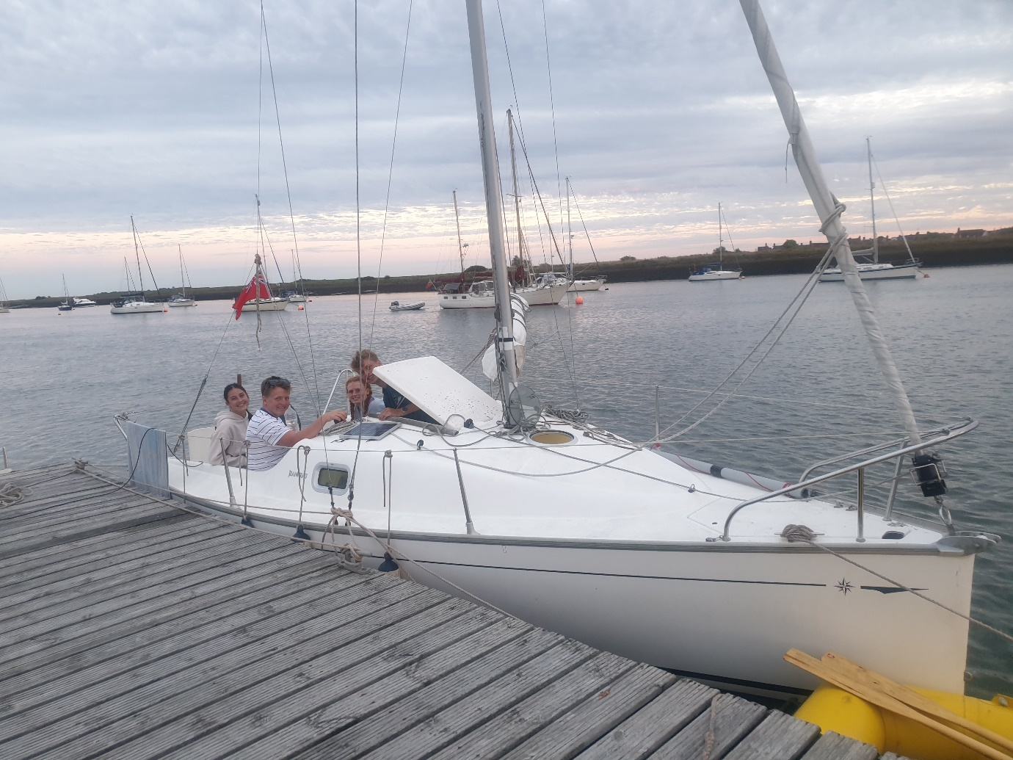
Fig14 | 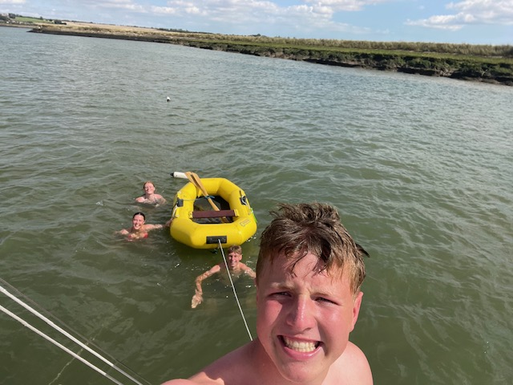
Fig15 | 